

**EE 477W Principles of Engineering Design IV**

**Final Project Report**

**Department of Electrical and Computer Engineering and Technology**

**Fall 2025**

**RAL Turret Loader Upgrade**

**Submitted by:**

Omar Elkenawy

Dagmawi Abera

Hamede Abdulgafur

**Submitted on:** May 2, 2025

Table of Contents

Abstract i

Acknowledgments ii

List of Figures ii

**1.** **Introduction** 1

1.1. Problem Statement 1

1.2. Objectives and Goals 1

1.3. Project Motivation and Significance 2

2. Background and Literature Review 2

2.1. Relevant Technologies and Prior Work 2

2.2. Engineering Standards Considered 3

2.3. Applicable Codes and Regulations 4

3. Project Requirements and Specifications 4

3.1. Customer/Stakeholder Needs 4

3.2. Functional and Non-Functional Requirements 5

3.3. Design Constraints (Technical, Economic, Environmental, Ethical, etc.) 6

4. System Design and Methodology 10

4.1. Overall System Architecture 10

4.2. Hardware Design 11

4.3. Software Development 12

4.4. Circuit and PCB Design 13

4.5. Safety and Risk Analysis 14

5. Implementation and Testing 15

5.1. Prototyping and Development Process 15

5.2. Test Plan and Procedures 15

5.3. Performance Evaluation 16

5.4. Results and Discussion 17

6. Integration of Coursework in Design Project 17

6.1. Key Courses That Contributed to the Project 17

6.2. Application of Course Topics in Design 18

6.3. Skills Developed from Academic Coursework 19

7. Project Management and Budget 19

7.1. Work Breakdown Structure 19

7.2. Gantt Chart and Milestones 20

7.3. Budget and Cost Analysis 21

8. Conclusion and Future Work 27

8.1. Summary of Achievements 27

8.2. Challenges Faced 27

8.3. Recommendations for Future Development 28

9. References 28

10. Appendices 30

10.1. Datasheets, Schematics, and Code Listings 30

# Abstract

The main intention of this project was to modernize and automate the core loading system in the RAL production line at Taylor Corporation. The actual intention was to replace an outdated and unreliable control system with a PLC-based system that would improve system reliability, maintainability, and operability. An Allen-Bradley Micro820 controller was selected as the central controller for the system and programmed using Connected Components Workbench (CCW) to manage the sensor inputs, solenoids, and safety interlocks.

The new system fully automates the core transfer sequence by feeding cores through a vibratory bowl feeder, transporting cores along a conveyor track, and ultimately positioning the cores for loading onto a turret rewinder using pneumatic master actuators. The former manual process required constant human interaction and supervision and was prone to malfunctions. The new logic-based control system manages the core loading process autonomously and has improved both respond time and operational consistency.

To accompany the upgrade control system, we created a custom electrical panel on using AutoCAD Electrical. The panel integrates all control components, power distribution, wiring, and more into a clean and traceable layout which facilitates the initial install and any future maintenance. We have included all necessary components to achieve industrial safety and allow engineering access for future programming; safety relays, contactors, terminal blocks, and also a grace port.

Ultimately, the upgrade reduced operator involvement into the automation, streamlined troubleshooting for indicator outputs and created a scalable platform for future integration and upgrades. In addition, the upgrade provided real hands-on experience in PLC programming, sensor integration, panel wiring and design and implementation of industrial safety systems which allowed a tie between academic principles and engineering principles in practice.

# Acknowledgments

We would like to express my sincere gratitude to the engineering team at Taylor Corporation for the opportunity to contribute to the RAL Core Feeder Upgrade project. I am especially thankful to **Lance Noska**, Controls Engineer and project mentor, for his guidance, technical insight, and continued support throughout the development process. I would also like to thank **Jeff** for his hands-on assistance and expertise during the electrical panel wiring and assembly. Their support was invaluable in bringing this project to completion. Lastly, I appreciate the encouragement and oversight provided by my course instructors and university for making this real-world learning experience possible

# List of Figures

Figure 1 Core Loader Demo Unit Setup on Test Bench 12

Figure 2 Final Assembled Electrical Control Panel 12

Figure 3 Electrical Panel Front View with E-Stop, Indicator Light, and Grace Port 13

Figure 4 CAD Model of RAL Loader Main Assembly by Taylor Corporation. 14

Figure 5 Gantt Chart 22

Figure 6 Power and I/O Wiring Diagram 32

Figure 7 Safety Relay and Emergency Stop Circuit 33

Figure 8 PLC I/O Mapping and Field Device Connections 34

Figure 9 Ladder Logic – System Initialization Sequence 35

Figure 10 Ladder Logic – Main I/O Control Logic 36

Figure 11 Ladder Logic – Bowl Feeder Control 37

Figure 12 Ladder Logic – Core Transport and Vacuum Sequence 37

Figure 13 Ladder Logic – Core Transfer and Positioning Logic 38

Figure 14 Ladder Logic – Load Actuator and Sequence Completion 39

Figure 15 Ladder Logic – Core Loader Retraction and Reset Sequence 39

Figure 16 Ladder Logic – Final Positioning and Sequence Reset 40

# List of Tables

Table 1Bill of Materials 28

# **Introduction**

## Problem Statement

The existing core feeding system at Taylor Corporation on the RAL production line had outdated equipment and limited automation capabilities. The system had not been updated or optimized for quite some time. It provided no standard and easy means of troubleshooting or making potential changes to the incompletely wired inputs and outputs. The reliance on manual operation clearly slowed production, but it also reduced quality, consistency, and increased the likelihood of mistakes. The inability to set up a modern day PLC-based control system with reliable sensor feedback further limited production performance and future scalability of the production line.

## Objectives and Goals

The main objective of this project was to modernize and automate the core loading process to improve efficiency, consistency, and serviceability. The key goals were:

* Implement a new PLC control system using the Allen-Bradley Micro820 and Connected Components Workbench (CCW)
* Replace the existing control panel with a redesigned version built using AutoCAD Electrical
* Integrate new actuators, sensors, and safety components into the control logic
* Ensure a sequential, automated process for loading cores onto the turret rewinder with minimal manual input
* Improve long-term supportability, diagnostic visibility, and system scalability

## Project Motivation and Significance

This project was initiated in response to Taylor Corporation's desire for increased automation to lower labor costs and to increase equipment reliability. Automating the core loading system will lead to increased efficiency in production as well as reduced operator fatigue and possibility for making an error. The new upgrade allows for repeatable core placement, improved integration with upstream and downstream equipment, and it builds a foundation for future upgrades. The project also served as valuable hands-on experience in the fields of PLC programming, industrial automation, and electrical panel design, thus connecting thoughts learned in school to actual engineering work.

# Background and Literature Review

## Relevant Technologies and Prior Work

The RAL Turret Core Loader system is an automation of the process of paper core insertion into a turret mechanism for rewinding. These applications are common in paper, film, and textile factories where cylindrical cores must be loaded precisely for subsequent material winding.

Technologies used in this project include:

PLC (Programmable Logic Controller): Specifically, an Allen-Bradley Micro820, which is used to implement flexible, real-time logic control of motors, solenoids, and sensors incorporated into the core loading process.

Connected Components Workbench (CCW): The software platform used to configure the Micro820 controller, create ladder logic, assign I/O, and simulate program logic.

AutoCAD Electrical: Used to create, revise, and finalize electrical panel schematics, document wiring connections, and ensure consistency with industrial standards.

Sensor Feedback Systems: With photoelectric sensors, vacuum sensors, and limit switches to provide immediate feedback and transition between the automated steps. The system will employ a pneumatic actuation to control the movements of the vacuum arm and actuator extension into the turret. MOV-Based Step Sequencing: A modular, structured way to control states in PLC logic. Each step moves forward only after verifying sensor feedback and timer completion.

Earlier work in industrial automation demonstrates that modular, state-based logic enhances maintainability, safety, and traceability of machine control. Reduced runtime errors and simplified troubleshooting during commissioning are the outcome of coupling solid sensor feedback with sequenced logic.

## Engineering Standards Considered

Several industry-accepted engineering standards impacted the design, programming, and panel building of this project:

IEC 61131-3: Industry standard for industrial PLC programming languages like ladder logic, which guarantees consistency and modular design principles.

NFPA 79: The Electrical Standard for Industrial Machinery, as a source of wiring practice, panel layout, fusing, and emergency stop circuits.

ISA 5.1: Instrumentation symbols and identification standard that was used to shape I/O labeling, documentation, and schematics of the electrical system.

Allen-Bradley Application Guidelines: Manufacturer-specific recommendations for wiring, grounding, spacing, and programming best practices, with particular focus on Micro800-series controllers.

These standards helped to align the project with professional engineering practices and ensured the finished design could be sustained and expanded upon in an industrial setting.

## Applicable Codes and Regulations

The system upgrade and automation design adhered to key safety and compliance codes, including:

OSHA (Occupational Safety and Health Administration): Ensured proper machine guarding, lockout/tagout (LOTO) capability, and emergency stop integration.

UL 508A: Industrial control panel safety requirements, which include the selection of components, fuse ratings, and layout of electrical hardware.

NEC (National Electrical Code): Applied to the sizing of wire, fuse coordination, grounding, and electrical safety of the control panel.

ISO 13849: Machinery safety standard, specifically in assessing the performance and design of the emergency stop loop and sensor interlocks.

In addition, Taylor Corporation's internal electrical standards were considered during the design of the system to ensure compatibility with existing production infrastructure and maintenance expectations.

# Project Requirements and Specifications

## Customer/Stakeholder Needs

The main stakeholder, Taylor Corporation - Label Works Division required a new core loading system that could:

1. Automate the manual process of loading paper cores onto a turret rewinder.
2. Improve the consistency and throughput of core feeding; reduce operator intervention.
3. Achieve safety and reliability through the use of sensor feedback and emergency stop control.
4. Deliver a scale, clean and maintainable electrical and control system.
5. Facilitate future diagnostics and upgrades.

These needs were articulated by controls engineer Lance Noska and other Taylor engineering team members, and some assistance from wiring technician Jeff.

## Functional and Non-Functional Requirements

***Functional Requirements***

The system must:

1. Automatically transfer paper cores that are fed from a vibratory bowl feeder onto a CTC turret rewinder.
2. Check for core presence, actuator positions, and turret alignments with integrated sensors.
3. Control pneumatic actuators for vacuum, rotation, extension and loading with PLC output signals.
4. Use PLC logic to execute a step-by-step sequence for engine core movement with a clear understanding of core tracking.
5. Safety feature - manual override or emergency stop.
6. Provide external access to the PLC using original Grace Port for programming and diagnostic interface.

***Non-Functional Requirements***

The system should:

1. Sustain consistent operations throughout long production runs with limited operator adjustments.
2. Be easy to maintain, with all wiring clearly labeled and no mess in the panel layout.
3. Use industrial-quality components to allow for long-term supportability and parts availability.
4. Be expandable to allow for further I/O expansion or logical adaptation in future re-evaluations.
5. Be safely and reliable in a normal indoor manufacturing environment.

## Design Constraints (Technical, Economic, Environmental, Ethical, etc.)

The design of the new RAL core feeder system involved many constraints, affecting the selection of components, programming approach, and electrical design methodologies. These constraints ensured that the project would meet the required real-world parameters around safety, cost, and future extensibility.

**Economic Constraints**

Application to Project: The limitations imposed by the budget forced us to reuse existing hardware pieces (vibratory bowl feeder and core conveyor) to complete the project on budget.

Design Modifications: We used more economical, but still effective hardware components (e.g., we used the Allen-Bradley Micro820 PLC, as opposed to PLCs with additional features) and re-used wiring hardware when we could.

Challenges: Some features (e.g., touchscreen HMI or advanced remote diagnostics) were not pursued due to the budget constraints.

Example: We selected a manual control box option instead a touch screen option that resulted in about $500 less in hardware cost.

**Environmental Constraints**

Application to project: The system operates in a clean indoor production environment, with limited dust, no moisture, and no extremes in heat.

Design changes: Standard IP rated enclosures and components were sufficient; there was no need for industrial grade waterproofing or HVAC components.

Challenges: The existing production area limited the amount of space available for panel layout.

Example: Smaller DIN-rail terminal blocks were used to minimize the panel size without restricting cable management and labeling.

**Social Constraints**

Application to Project: The aim was to reduce labor tasks and enhance operator experience.

Design Changes: Simple repetitive tasks, such as loading a core manually, were automated in order to free up operators for more valuable work.

Challenges: The design had to remain intuitive and reliable for operators who would have never worked with P.E.L. systems.

For example: We labeled all wiring harnesses, and we added an indicator LED as a simple debug mechanism for operators without deep training on P.L.C. systems to check core output before replacing modules in limited timeframes.

**Political Constraints**

Application to Project: Must use company-approved vendor lists and industry compliance stipulations.

Design Changes: All parts specified were purchased through approved sources (e.g., Van Meter, IFM) to comply with purchasing policies from the company.

Struggles: The inflexibility of selecting cheaper or quicker ship options from unapproved sources.

Example: We could have sourced a similar solenoid from non-approved vendors, but we ensured internal compliance by sourcing IFM-approved parts.

**Ethical Constraints**

Application to Project: Safety and reliability took precedence to cost saving; we would not take any shortcuts that created risk.

Design Changes: The use of safety relays and dual-contact emergency stops followed the ethical engineering principles.

Challenges: Added some additional wiring and time on setup, however, overall the build phase was only marginally longer.

Examples: In order to achieve proper fail-safe behavior, instead of directly breaking the control circuit with the E-stop, we used a separate safety contactor.

**Health and Safety Constraints**

Application to the Project: All moving motors/actuators needed to respond to E-stop commands and stop the motion as fast as possible.

Design Change: The system contains a hard wired emergency stop loop through a safety controller (IFM G1501S).

Challenges: The integration of safety and automation was very complicated and planning out all the I/O was critical to not have false trips.

Example: We differentiate standard inputs from safety inputs and also have visual indicators (E-stop LED) that give the user confirmation of the status of the system.

**Manufacturability Constraints**

Applying it to the Project: The control panel needed to be small, clearly labeled and straightforward to build up on location.

Design Changes: To create distinct and clear wire pathing layouts, we used AutoCAD Electrical to structure consistent component layouts.

Challenges: The space allowed in enclosures dictated the need to efficiently devise arrangements for I/O terminals.

Example: Cable entry was designed with bundling of glands and ferrules to facilitate subsequent troubleshooting.

**Sustainability Constraints**

Application to Project: Long-term maintainability was a design requirement.

Design Changes: Standard off-the-shelf components were used only, no proprietary parts.

Challenges: Balancing the issues related to the ease of replacement, costs and performance.

Example: The Grace Port was included to provide PLC access without opening the panel, minimizing wear and risk over the long run.

# System Design and Methodology

## Overall System Architecture

RAL Turret Core Loader is a robotization of cardboard core loading into a revolving turret. It consists of three coordinated subsystems:

Bowl Feeder: Unloads cores onto a belt through a run command by steps.

Core Transport: Moves the core from the feeder to the turret through a conveyor belt and stop gate.

Core Rotate & Load: Employs a vacuum-fit pivot arm to rotate and load the core into the turret.

All subsystems are powered by an Allen-Bradley Micro820 PLC via Connected Components Workbench (CCW). Logic is broken down into modular, MOV-based sequencers for control of transitions through sensor feedback and timers.

## Hardware Design

The new hardware system replaced the legacy control system with a new industrial-grade control panel and mechanical components. Some of the key components are:

* **Allen-Bradley Micro820 PLC (2080-LC20-20QWB)** for centralized control logic
* **IFM DN4013 24VDC Power Supply** to supply power to sensors, solenoids, and the PLC
* **IFM G1501S Safety Controller** with E-stop integration and LED indication
* **Oriental Motor BLE2D60-A Drive** for controlling conveyor movement
* **Solenoids and relays** to control:

1. Bowl Feeder
2. Core Stop Gate
3. Vacuum Suction
4. Arm Rotation
5. Actuator Extension
6. Wiring schematics were created using **AutoCAD Electrical**, with correct I/O mapping, terminal identification, grounding, and power distribution.

Figure 1 Core Loader Demo Unit Setup on Test Bench

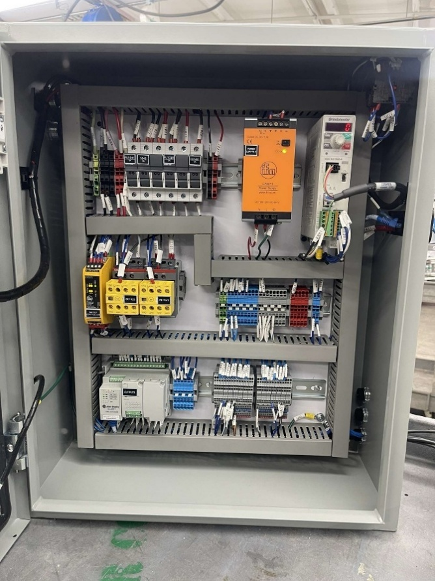

Figure 2 Final Assembled Electrical Control Panel

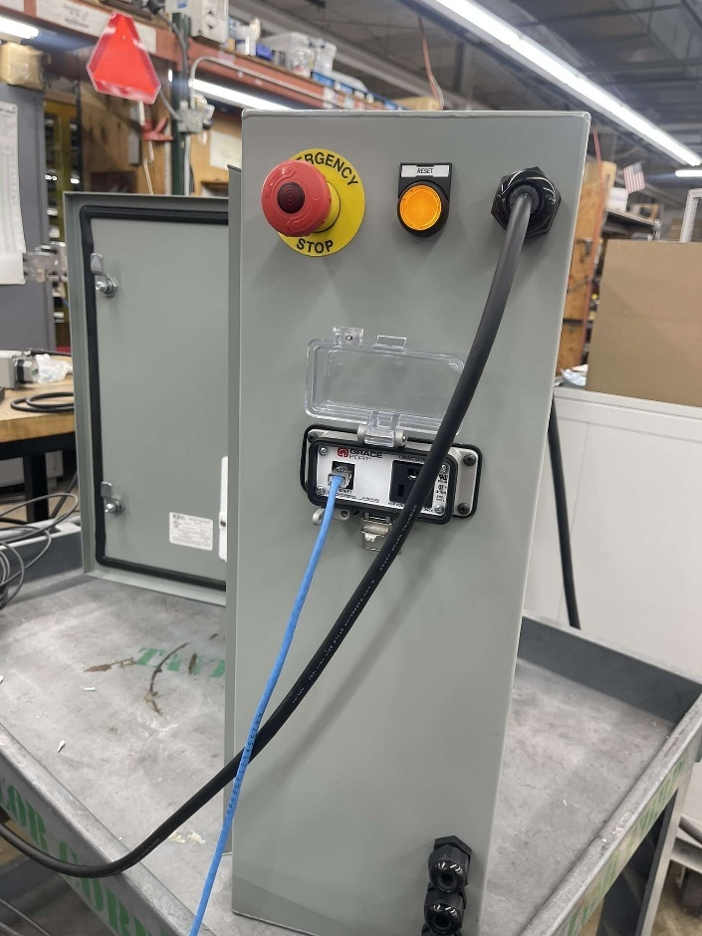

Figure 3 Electrical Panel Front View with E-Stop, Indicator Light, and Grace Port

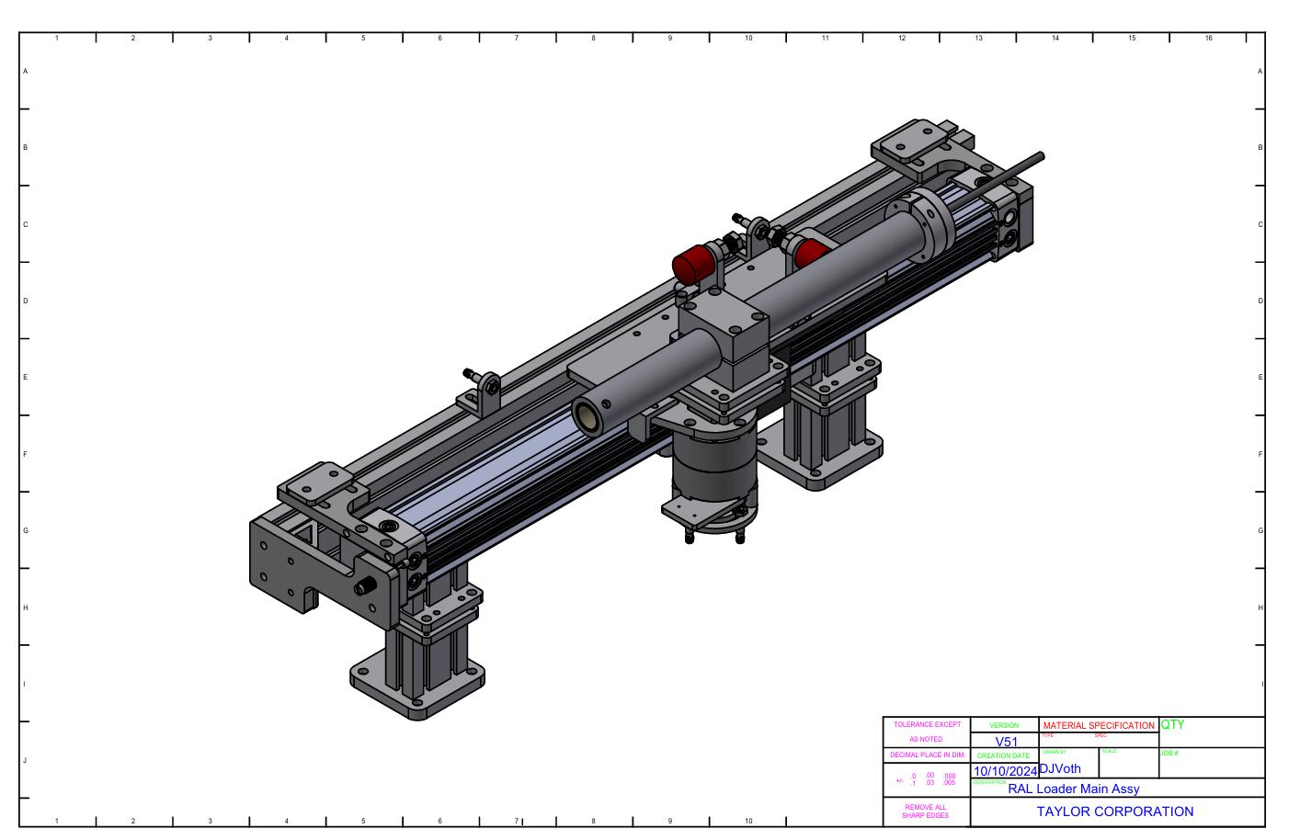

Figure 4 CAD Model of RAL Loader Main Assembly by Taylor Corporation.

## Software Development

The automation program was written in ladder logic within **Connected Components Workbench (CCW)**. Logic was segmented into modular sequences:

* **BowlFeeder_Seq:** Controls feeder run until belt is full
* **CoreTransport_Seq:** Drives conveyor and stop gate through sensors and timers
* **CoreRotateLoad_Seq:** Controls vacuum pickup, pivot rotation, turret signal sync, and actuator extension
* **Notable features of the logic:**
* MOV-based sequencing to transition between steps
* TON and RTO timers for process synchronization and delays
* Safety validation checks on all outputs
* Integrated safety controller and emergency stop interlocks
* Reset logic on power-up through __SYSVA__ST_SCAN system bit
* Testing and validation were conducted both in hardware and simulation to verify accuracy.

## Circuit and PCB Design

Even though a PCB was not necessary, the electrical panel was designed as per industrial best practices:

Panel layout and schematics drawn using **AutoCAD Electrical**

* I/O mapping in conjunction with component placement to allow easy wiring and troubleshooting
* Logic and power isolated from one another to maintain PLC and sensor control separate from solenoid and drive power
* Circuits fused with 5A and 4A fuses
* UL 508A wiring practices, including:
* Shielded signal wiring
* Keep terminal blocks organized
* Components grounded to the chassis

The panel was created and tested in-house and will be reused in the end production deployment.

## Safety and Risk Analysis

Safety was a built-in design philosophy of this system. The features are:

* **Emergency Stop (E-stop)** circuitry to disable all motion control outputs
* **IFM G1501S Safety Controller**, which:
* Watches E-stop and safety relays (CR1921, CR1941)
* Feed back to both the PLC and status indicators
* **Sensor interlocks** which:
* Prevent actuator extension until turret is ready
* Disengage vacuum suction if core is not detected
* **Solenoid dump valve (SOL1661)** to depressurize the pneumatic system in fault
* Electrical protection through the use of properly rated fuses and segregated circuits

Each control phase included safety interlocks that were tested, and restarts were managed by utilizing the PLC's first-scan bit.

# Implementation and Testing

## Prototyping and Development Process

In displaying the functionality of the RAL Turret Core Loader automation system, our group developed a full-capacity demo unit that almost perfectly replicates the mechanical progression of the system. This is a scaled-down representation of the end plant execution.

The design phase began with a review of the existing core loader system and identifying manual procedures that needed to be automated. We worked closely with Taylor Corporation engineers to define control needs, I/O requirements, and hardware constraints.

Using Connected Components Workbench (CCW), we designed and verified ladder logic before it was implemented on physical hardware. We built the electrical panel using an Allen-Bradley Micro820 PLC, solenoids, relays, safety controller, and drives after simulated testing. We designed the wiring schematics on AutoCAD Electrical, where connections and labels were exactly the same as the structure of logic.

The demo unit was then integrated with pneumatic and mechanical components in a testbed to allow us to extensively test and optimize the sequencing, timing, and safety. Once proven, the system will be ready to be finalized in integration into the Label Works factory at the end of the semester.

## Test Plan and Procedures

The team developed a subsystem-by-subsystem test plan to test every subsystem in isolation before integrating the whole system. Key procedures were:

**Bowl Feeder Subsystem Test**

* Check signal sends to bowl feeder solenoid
* Check stop on Core Belt Full sensor

**Core Transport Subsystem Test**

* Gate operation logic tested by discrete sensor inputs
* Conveyor drive activated by CCW control logic
* Timers tuned based on physical movement time

**Core Rotate & Load Subsystem Test**

* Vacuum suction triggered and checked with sensor feedback
* Arm rotation confirmed 90° rotation
* Extend and retract of actuator confirmed by limit switches
* Turret signal tested during correct step

All tests were inspected for proper MOV step changes, sensor output, and safety interlocks (E-stop and controller feedback). In case of a failed test, variables and timers were adjusted in the logic, and outputs were scoped for expected action.

## Performance Evaluation

The automatic loader was found to have the ability to:

* Continuously feed, move, and load cardboard cores without operator intervention
* Employ sensors to sense improper loading conditions
* Handle effective handling of emergency stop and fault indications
* Perform each sequence step within industrial timing tolerances (1–3 second ranges)

Testing confirmed all physical motion occurred as expected, with transition delays being calibrated using TON timers. The modularity of logic allowed quick debugging and rewrites of logic when modifying gate timing, pivot rotation, or actuator duration.

## Results and Discussion

The demo system completely automated the RAL turret core loader process to huge success. Some of the significant results were:

* Uniform sequence of cardboard core feeding, transport, and turret loading
* Proper synchronization of sensor feedback and mechanical movement
* Proper execution of timing-critical operations like pivoting and loading
* Proper response in the event of emergency stop and power reset

This prototype allowed our team to simulate and test actual production logic in controlled conditions. The modularity and MOV-based timing simplified debugging, and timing or sensor feedback problems were readily solved.

In the future, the established logic, panel layout, and schematics will be transferred to the actual RAL line at Label Works, where this system will be installed to automate core loading on a full production scale.

# Integration of Coursework in Design Project

## Key Courses That Contributed to the Project

Several courses at Minnesota State University, Mankato directly supported the technical and project management aspects of the RAL Core Feeder Upgrade, including:

* **EE 234 – Microprocessor Engineering I**: Introduced foundational concepts in digital logic, timing, and I/O that relate closely to PLC-based control systems.
* **EE 235 – Micro Lab I**: Reinforced hands-on experience with embedded systems and microcontroller I/O, similar to PLC programming and sensor integration.
* **EE 336 / 337 / 467W – Engineering Design I–III**: Provided a structured approach to defining engineering problems, conducting research, prototyping, and documenting project deliverables.
* **EE 390 – Smart Sensor Systems**: Offered insight into the operation and selection of industrial sensors used for system feedback and control.
* **EE 245 – Robotics Programming**: Built foundational knowledge in sequencing actuators and working with automation logic.
* **EE 358 / 368 – Control Systems + Lab**: Explored system dynamics and response, essential for understanding the coordination of actuators and system timing.
* **ENG 271W – Technical Communication**: Strengthened documentation, reporting, and communication skills required for professional engineering reports.

## Application of Course Topics in Design

Smart sensor systems and controls were used for the sensor selection and feedback logic in coded logic to determine vacuum, turret position, and actuator state. Microprocessor and robotics courses were utilized to adapt PLC logic regarding sequencing motion through internal control bits and output instructions. The engineering design courses continued to support system planning, Gantt chart stages, technical reviews, and overall project documentation. The technical communication course assisted in writing the final report, formatting deliverables, and advancing communication regarding progress to mentors and stakeholders.

## Skills Developed from Academic Coursework

Demonstrated structured thought process in the creation of step-by-step PLC sequences for actuator controls and feedback from sensors. System-Level Integration: Developed the capability to coordinate multiple hardware components working with a central control program. Technical Document Creation: Practiced formal technical document creation (ladder logic, schematics, project reports) following parallel industry standards. Collaborative Problem Solving: Obtained practical experience working in teams, interpreting technical drawings, and incorporating stakeholder input into current and evolving designs. Project Management: Enhanced ability to manage timelines, track deliverables, and maintain version control throughout the design-build-test process.

# Project Management and Budget

## Work Breakdown Structure

This project was completed by a team of three students working in close collaboration. Instead of assigning individual responsibilities to specific team members, the group made a shared commitment to work on all aspects of the project together. This collaborative approach allowed each member to:

* Learn the full life cycle of an industrial automation project
* Gain hands-on experience in ladder logic programming, electrical panel design, and pneumatic integration
* Contribute equally to problem-solving, wiring, and testing

The work breakdown was therefore horizontal and experience-driven, covering:

* PLC programming and sequencing logic
* Panel layout, wiring, and testing
* Sensor and actuator integration
* Documentation and schematics using AutoCAD Electrical
* Troubleshooting and simulation
* Presentation and report preparation

This cooperative structure created a stronger understanding of each subsystem and built confidence in every stage of automation system design and deployment.

## Gantt Chart and Milestones

Below is a simplified version of the major milestones and timeline followed during the semester: 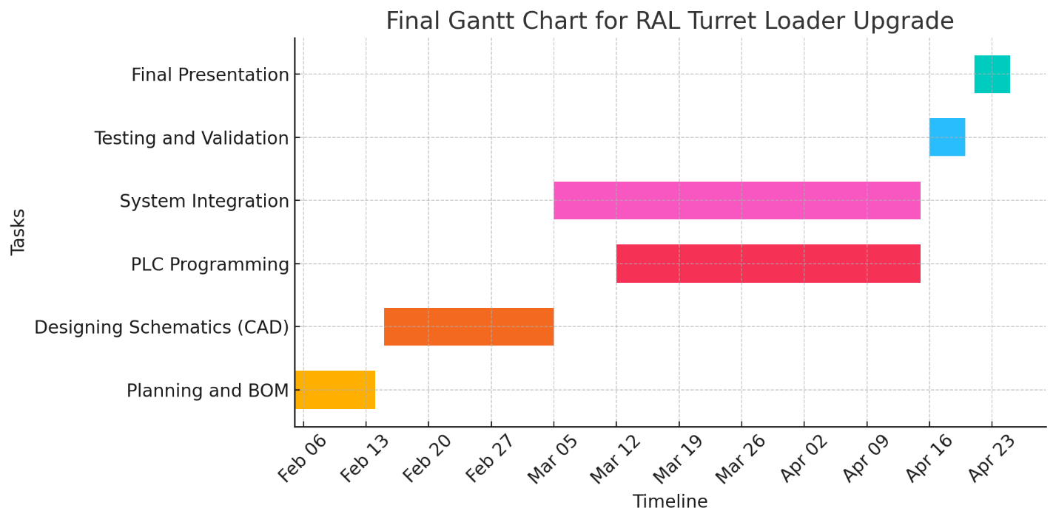

Figure 5 Gantt Chart

Each phase was discussed and divided informally during weekly meetings, with all team members participating in implementation and review.

## Budget and Cost Analysis

The total estimated cost of the project is based on hardware components, wiring materials, safety devices, and automation equipment. The budget was provided in collaboration with Taylor Corporation and tracked using a shared spreadsheet.

|  |  |  |  |  |  |  |
| --- | --- | --- | --- | --- | --- | --- |
| **Electrical Parts List** | | | | | | |
| **Project Name: RAL Turret Loader** | | | | | | |
| **Description** | **Quantity** | **Quoted / Cost** | **Excluded Qty** | **Total Cost** | **Ordered** | **Received** |
| .235 Inch Permasleeve Wire Label | 3 | 77.39 |  | 232.17 |  |  |
| Self Laminating Vinyl (1" x 0.75" x 0.375") (340 LPR) | 1 | 83.59 |  | 83.59 |  |  |
| 4 Amp Fuses (10 Pack) (Current Limiting) (CC Class) | 1 | 132 |  | 132 |  |  |
| 5 Amp Fuses (10 Pack) (Current Limiting) (CC Class) | 1 | 125 | 1 | 0 |  |  |
| 18 AWG Red Ferrule (10mm Pin) (Large Cap) (500 Pack) | 2 | 9.9 |  | 19.8 |  |  |
| 20 AWG White Ferrule (10mm Pin) (500 Pack) | 1 | 7.37 |  | 7.37 |  |  |
| 22 AWG Teal Ferrule (8mm Pin) (500 Pack) | 1 | 9.84 |  | 9.84 |  |  |
| CC Class LED Indicating Fuse Block (1-Pole) | 1 | 6.9429 |  | 6.9429 |  |  |
| CC Class LED Indicating Fuse Block (2-Pole) | 2 | 19.7571 |  | 39.5142 |  |  |
| ILL. Emergency Stop PB (Twist Release) | 1 | 30.7 |  | 30.7 |  |  |
| Emergency Stop Name Plate (Yellow Ring) | 1 | 1.4 |  | 1.4 |  |  |
| Red LED (E-Stop PB LED) | 1 | 16.1286 |  | 16.1286 |  |  |
| N.C Contact Block | 3 | 5.6 |  | 16.8 |  |  |
| N.O Contact Block | 1 | 5.6 |  | 5.6 |  |  |
| Plastic Mounting Latch For PB's | 1 | 2.4857 |  | 2.4857 |  |  |
| Screw-less End Stop | 15 | 0.992 |  | 14.88 |  |  |
| 2-Way Jumper For Sensor Terminals | 36 | 0.4296 |  | 15.4656 |  |  |
| Sensor Terminal Block | 18 | 7.6266 |  | 137.2788 |  |  |
| End/Intermediate Plate For Sensor Terminal Block | 2 | 0.8267 |  | 1.6534 |  |  |
| 2-Way Jumper For Terminals (20A) | 10 | 0.7736 |  | 7.736 |  |  |
| Gray Terminal Block (20A) | 5 | 1.56 |  | 7.8 |  |  |
| Blue Terminal Block (20A) | 15 | 1.52 |  | 22.8 |  |  |
| Ground Terminal Block (20A) | 2 | 5.112 |  | 10.224 |  |  |
| End/Intermediate Plate For Terminal Block (20A) | 5 | 0.7864 |  | 3.932 |  |  |
| Gray Terminal Block (50A) | 3 | 3.4267 |  | 10.2801 |  |  |
| Red Terminal Block (50A) | 3 | 3.4533 |  | 10.3599 |  |  |
| Black Terminal Block (50A) | 3 | 3.4533 |  | 10.3599 |  |  |
| Ground Terminal Block (50A) | 3 | 7.5333 |  | 22.5999 |  |  |
| End/Intermediate Plate For Terminal Block (30A) | 10 | 0.96 |  | 9.6 |  |  |
| 24VDC Power Supply (100V-240V Input) (10A) | 1 | 177.82 |  | 177.82 |  |  |
| Y/T Splitter (2x M8 Socket To 1x M12 Plug) | 3 | 11.61 |  | 34.83 |  |  |
| T-Slot Cylinder Sensor (0.5 M Lead) | 6 | 28.66 |  | 171.96 |  |  |
| Inductive Proximity Sensor (M8) | 4 | 56.35 |  | 225.4 |  |  |
| Female M12 Cable (5 Pin, Straight) (5M) | 5 | 8.73 |  | 43.65 |  |  |
| Female M8 Cable (3 Pin, Straight) (5M) | 5 | 5.53 |  | 27.65 |  |  |
| Safety Relay | 1 | 210.4 | 1 | 0 |  |  |
| Drive & Motor (60W 1/12 HP)(80-4000 RPM)(76 lb-in) | 1 | 636 | 1 | 0 |  |  |
| Safety Contactor (3 Pole) (9A 3Ø) | 2 | 107.69 |  | 215.38 |  |  |
| Electrical Enclosure (24H x 20W  x 8D) | 1 | 208.91 |  | 208.91 |  |  |
| Front Enclosure Subpanel (21H x 17W) | 1 | 37.27 |  | 37.27 |  |  |
| Push Button Box (2x 22.5mm PB) | 1 | 50.43 |  | 50.43 |  |  |
| Micro 820 Controller | 1 | 362.37 |  | 362.37 |  |  |
| 4 Point Relay Output Module | 1 | 81.47 | 1 | 0 |  |  |
| Cable Gland (1/2 Inch, Black) | 10 | 3.7158 |  | 37.158 |  |  |
| Locknut (1/2 Inch, Steel) | 10 | 0.2755 |  | 2.755 |  |  |
| Grace Port | 1 | 182 |  | 182 |  |  |
| 3 Pole Door Disconnect Kit | 1 | 127.9 |  | 127.9 |  |  |
| 10/4 Black SOOW Cable (0.76 Diameter) | 15 | 2.33002 |  | 34.9503 |  |  |
| 125/250V Plug L14-20P (20A) (Black/White) | 1 | 47.28 |  | 47.28 |  |  |
| 3/4 Aluminum Cord Grip (0.75" - 0.875" Opening) | 1 | 15.67 |  | 15.67 |  |  |
| 3/4 Steel Locknut | 1 | 0.36 |  | 0.36 |  |  |
| 18 AWG MTW (Blue) (500 Ft) | 1 | 60.65 |  | 60.65 |  |  |
| 18 AWG MTW (White w/ Blue Stripe) (500 FT) | 1 | 62.23 |  | 62.23 |  |  |

Table 1Bill of Materials

**Total Cost of Materials = $3,015.93**

No labor or software licensing costs were included, as all work was completed by the student team, and software was made available by the university and Taylor Corporation.

# Conclusion and Future Work

## Summary of Achievements

This project provided a significant modernization to the core feeder system on the RAL production line at Taylor Corporation, by moving from an obsolete relay-based control system to a fully automated PLC-based solution. The Allen-Bradley Micro820 controller was programmed with the Connected Components Workbench (CCW) to stage sensor inputs and actuator outputs to automate core loading. A complete new electrical panel was designed and fabricated with AutoCAD Electrical to streamline wiring clarity, shorten time spent troubleshooting, and enhance future scalability. The core loading system now operates with less manual labor, enhanced reliability, and the ability to consistently match loading performance.

## Challenges Faced

A number of challenges were faced during the project:

* Limited experience with the legacy system meant visiting multiple sites and reverse engineering old wiring diagrams.
* Hardware constraints, such as reduced Input Output capability on the Micro820, and limited space within a panel forced tight design and planning.
* Early logic errors were discovered while figuring out testing, to understand what sensor feedback was available, and focusing on safe, interruptible sequencing.
* Integrating safety with automation logic included learning about safety relays that were new and verifying things like E-stop.
* We overcame these challenges through collaboration with controls engineer Lance Noska, through hands-on troubleshooting, and through iterative refinements of conceptual design.

## Recommendations for Future Development

To further improve the system, we suggest the future improvements below:

* Add an HMI interface for operator feedback, real-time operating status, and manual operation in the event of maintenance.
* Adding diagnostics LEDs or status lights to the control panel will aid in quickly identifying faults and appropriate support.
* Include modular expansion such as I/O extension modules or remote I/O block to ease upgrades and changes to the system.
* Introduce cycle timing analysis to improve process speed and identify bottlenecks in high throughput situations.
* Logically document and digitally identify wire numbers using QR codes, or with database driven panel schematics will offer ease of long-term support.

# References

[1] Rockwell Automation, *Allen-Bradley Micro820 Programmable Logic Controller*, [Online]. Available: <https://www.rockwellautomation.com/en-us/products/hardware/allen-bradley/controllers/micro820.html>

[2] Rockwell Automation, *Connected Components Workbench (CCW) Software*, [Online]. Available: <https://www.rockwellautomation.com/en-us/products/software/factorytalk/connected-components-workbench.html>

[3] IFM, *G1501S Safety Controller Datasheet*, [Online]. Available: [https://www.ifm.com](https://www.ifm.com/)

[4] IFM, *DN4013 24VDC Power Supply Specifications*, [Online]. Available: [https://www.ifm.com](https://www.ifm.com/)

[5] Oriental Motor USA, *BLE2D60-A Brushless DC Motor Driver Datasheet*, [Online]. Available: [https://www.orientalmotor.com](https://www.orientalmotor.com/)

[6] National Fire Protection Association, *NFPA 70: National Electrical Code (NEC)*, 2023. [Online]. Available: [https://www.nfpa.org](https://www.nfpa.org/)

[7] Underwriters Laboratories, *UL 508A: Standard for Industrial Control Panels*, [Online]. Available: [https://www.ul.com](https://www.ul.com/)

[8] Autodesk, *AutoCAD Electrical: Electrical Design Toolset*, [Online]. Available: <https://www.autodesk.com/products/autocad/included-toolsets/autocad-electrical>

[9] Taylor Corporation, *RAL Line Integration Sponsor*, [Online]. Available: [https://www.taylor.com](https://www.taylor.com/)

# Appendices

## Datasheets, Schematics, and Code Listings

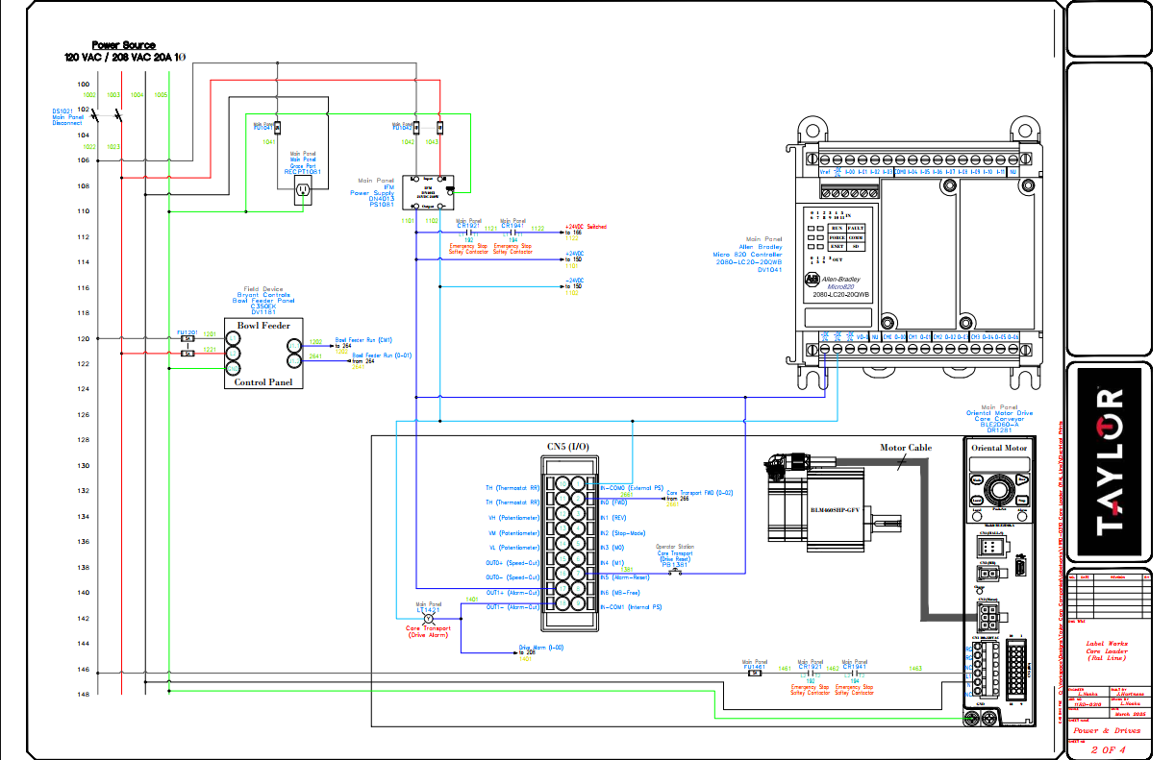

Figure 6Power and I/O Wiring Diagram

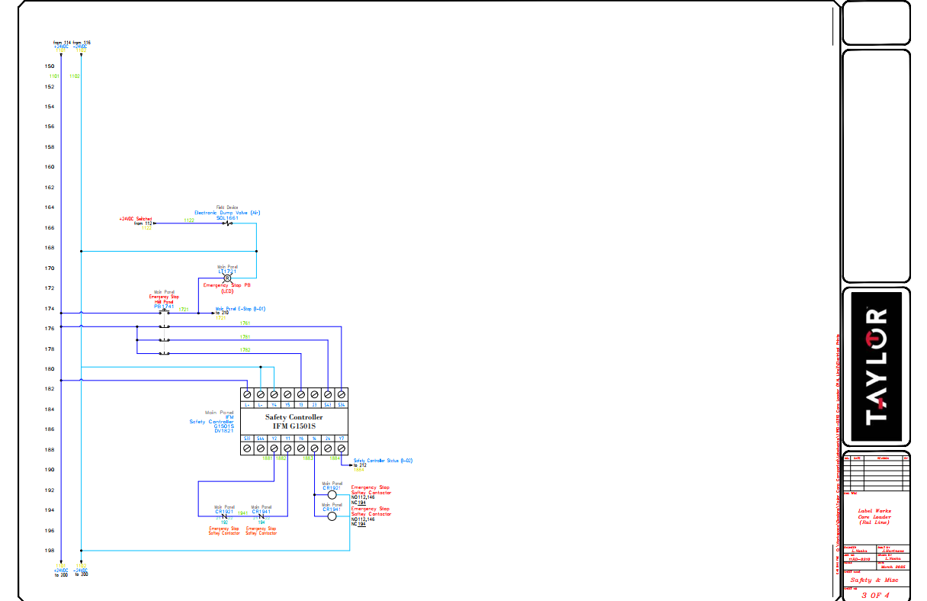

Figure 7Safety Relay and Emergency Stop Circuit

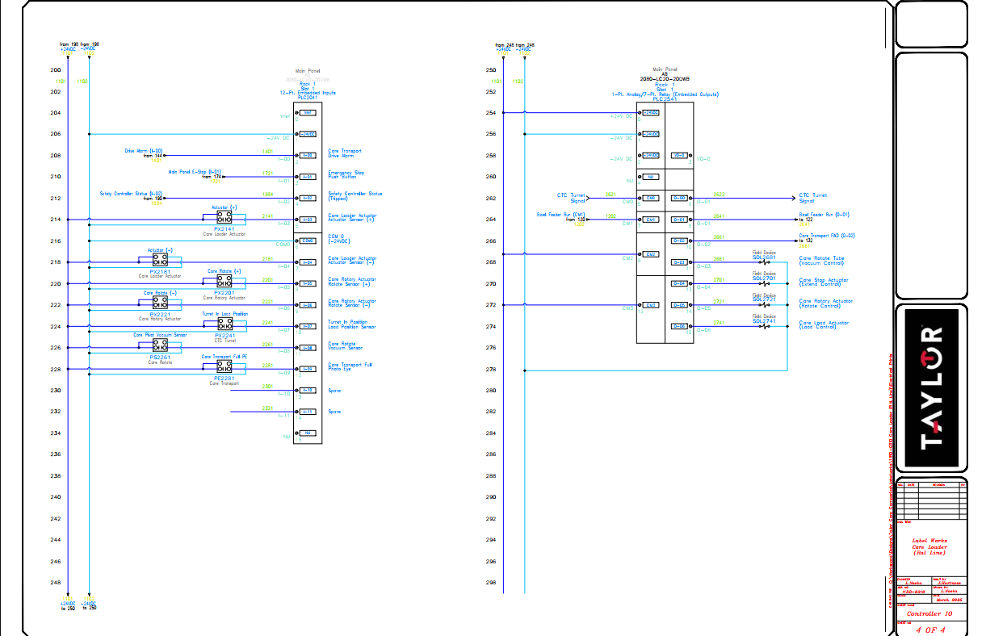

Figure 8PLC I/O Mapping and Field Device Connections

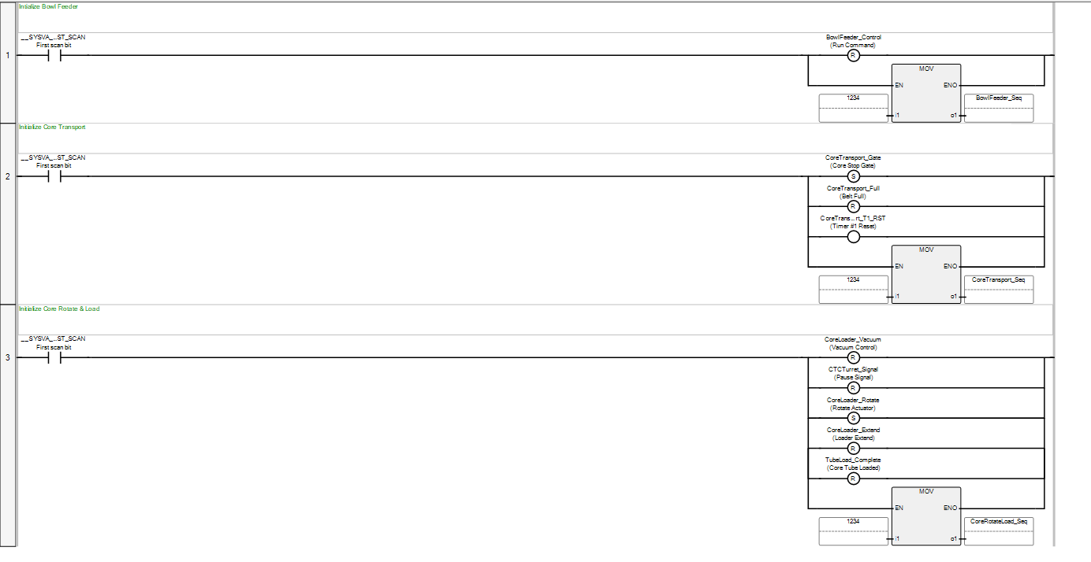

Figure 9Ladder Logic – System Initialization Sequence

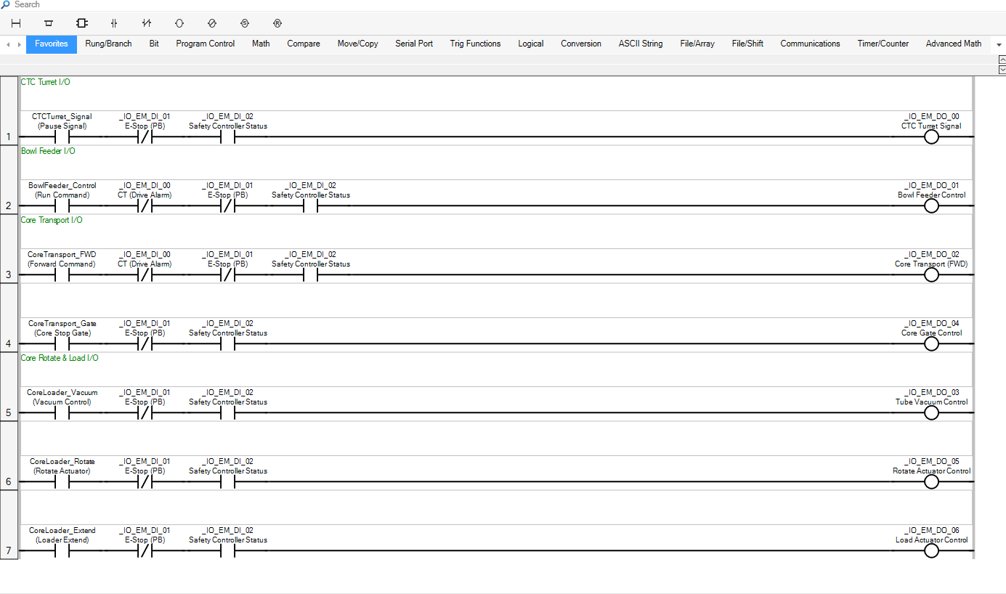

Figure 10 Ladder Logic – Main I/O Control Logic

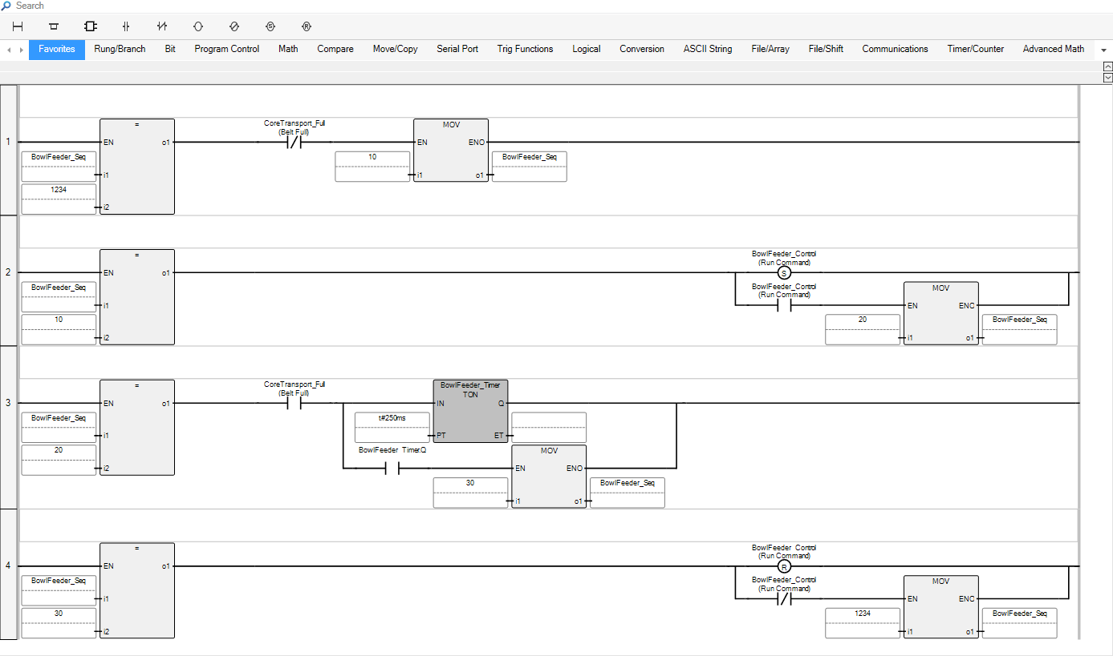

Figure 11 Ladder Logic – Bowl Feeder Control

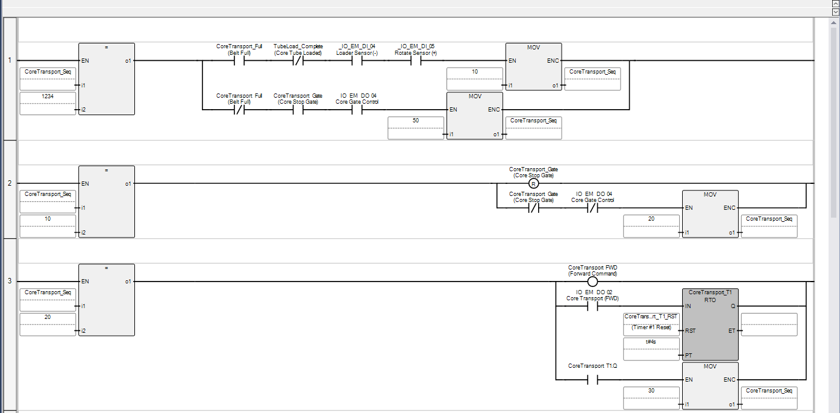

Figure 12 Ladder Logic – Core Transport and Vacuum Sequence

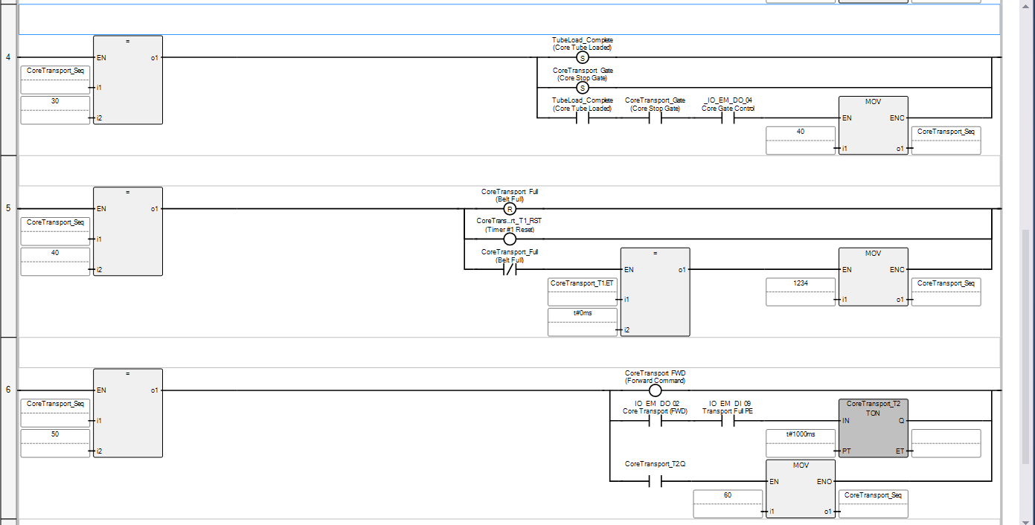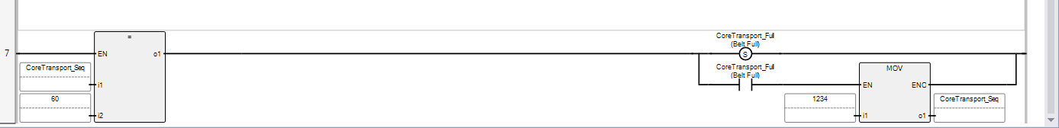

Figure 13 Ladder Logic – Core Transfer and Positioning Logic

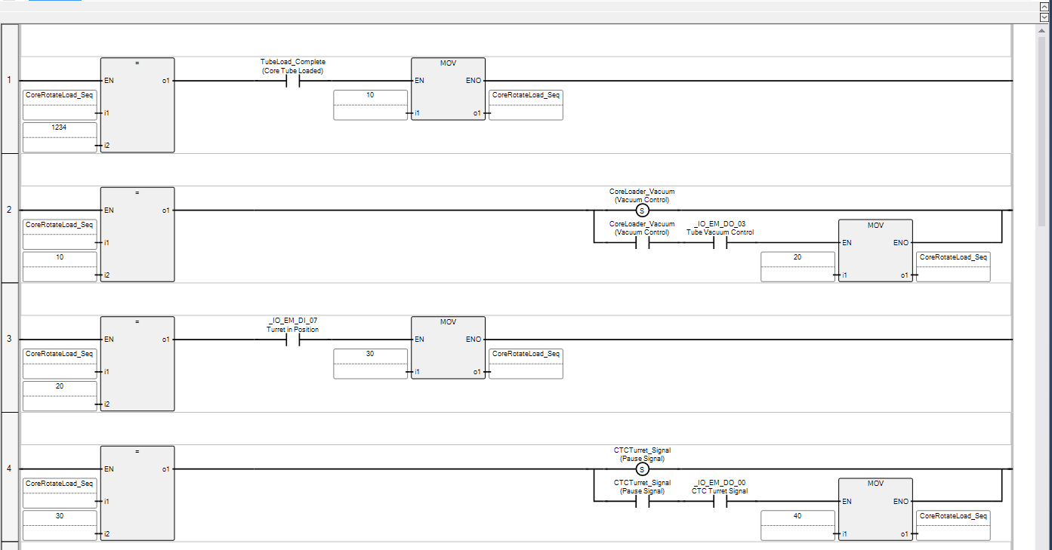

Figure 14 Ladder Logic – Load Actuator and Sequence Completion

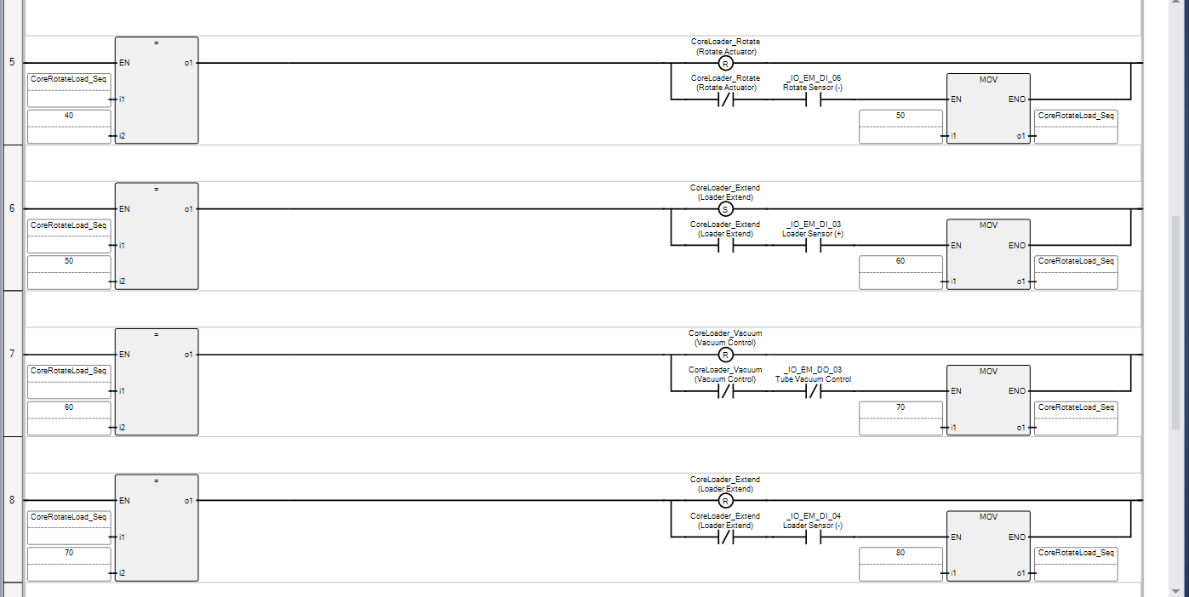

Figure 15 Ladder Logic – Core Loader Retraction and Reset Sequence

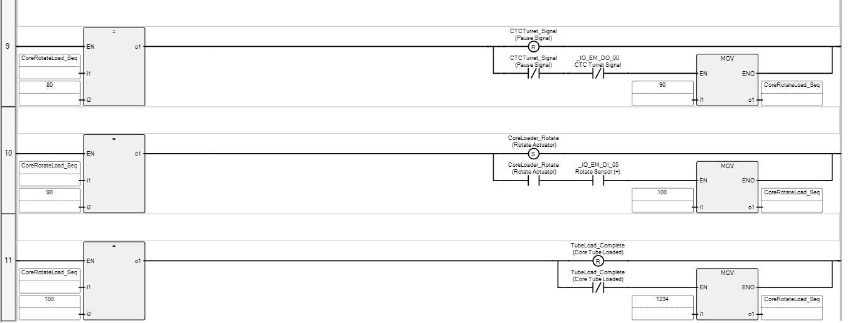

Figure 16 Ladder Logic – Final Positioning and Sequence Reset